Build Your Jenkins Job

1 - To create a Jenkins freestyle job, open your Jenkins installation path. It will be hosted on **http://localhost:8080** or **http://ec2-ip-address:8080** If you have installed to different port, please use this port number. Then log on to your Jenkins dashboard with username and password.

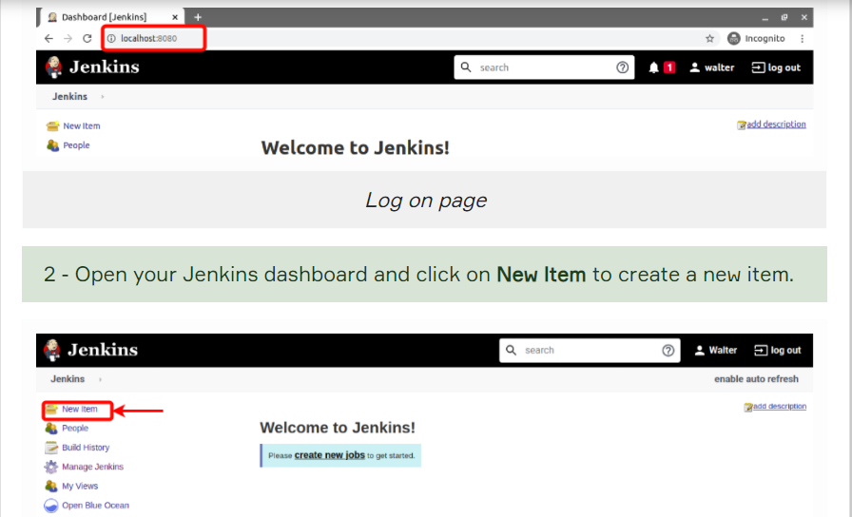

Enter the **item name** then select **free style project** and click to **OK**.

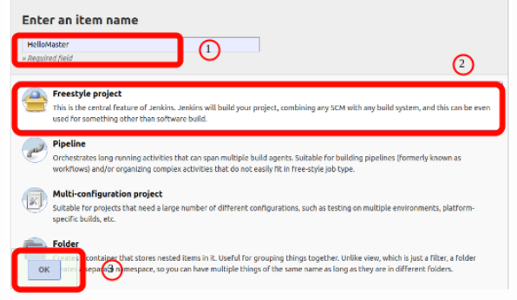

While creating first Project you will see six tabs. These are:

1. Source Code Management Tab : optional SCM(Source Code Management), such as CVS(Concurrent Versions System) or Subversion where your source code resides.
2. Build Triggers : Optional triggers to control when Jenkins will perform builds.
3. Build Environment: Some sort of build script that performs the build (ant, maven, shell script, batch file, etc.) where the real work happens
4. Build : Optional steps to collect information out of the build, such as archiving the artifacts and/or recording javadoc and test results.
5. Post-build Actions : Optional steps to notify other people/systems with the build result, such as sending e-mails, IMs, updating issue tracker, etc.
6. General :

4 - Specify your Jenkins project's **description**. Then go to **Build**.

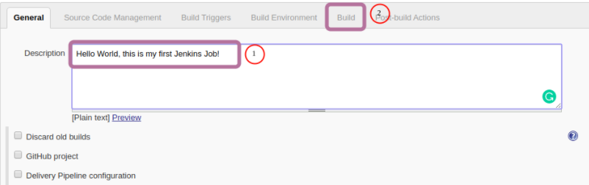

 Choose appropriate build step from "Add build step". It depends on your operating system. If you are windows user you can choose **Execute Windows batch command** or if you are using Linux or MacOS operating system, you can choose **Execute shell**.

When you select the build step, command space will be shown. Write down just **echo "Hello World"** to execute shell command/windows batch command.

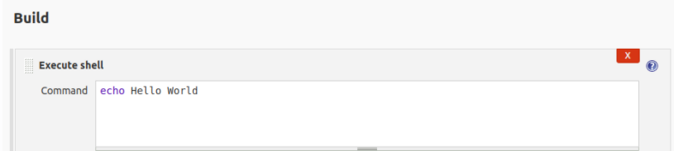

Then click **apply** and **save** button.  
After that you will see inside of the Project. Then click to **Build now** and wait a few seconds. You will see result of this build action under the **Build History**

As we mentioned above you will see the results of the build. If you click to the build number, you can reach build page. If you see the number blue that means build worked well.

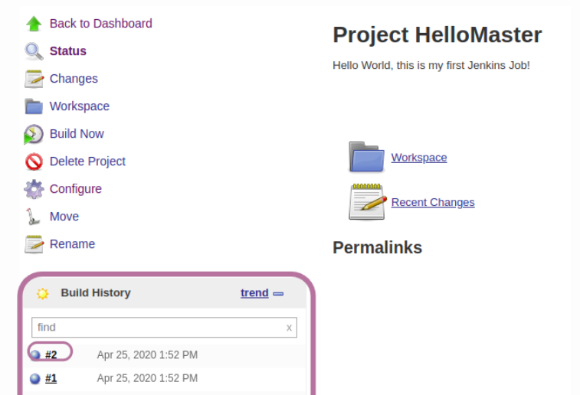

From build page you can see console results from "Console Output".

You can see results of your build. As you can see our result our job printed out to "Hello World" and it finished with "SUCCESS".

